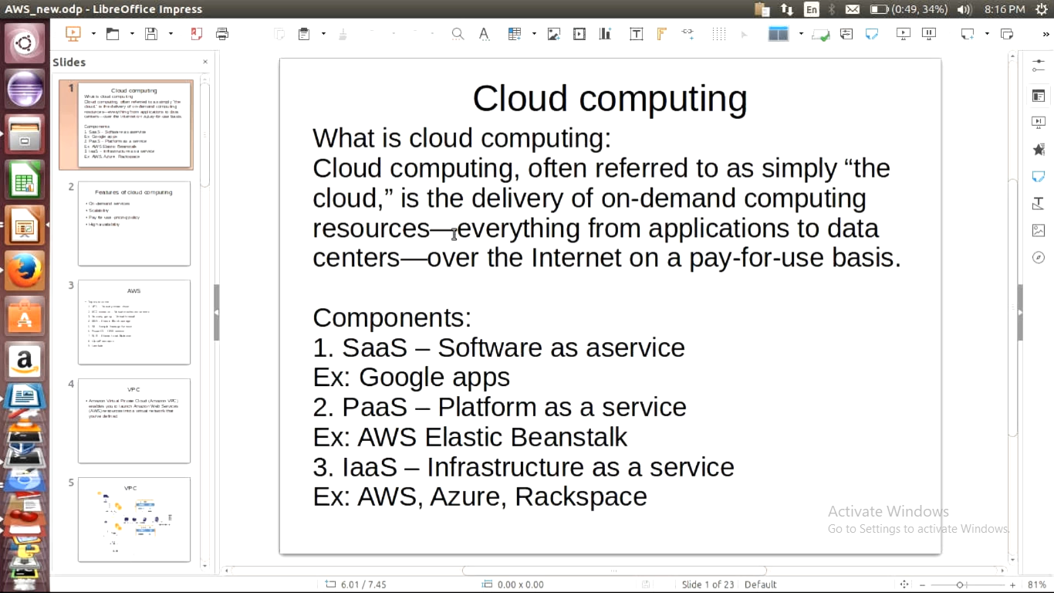

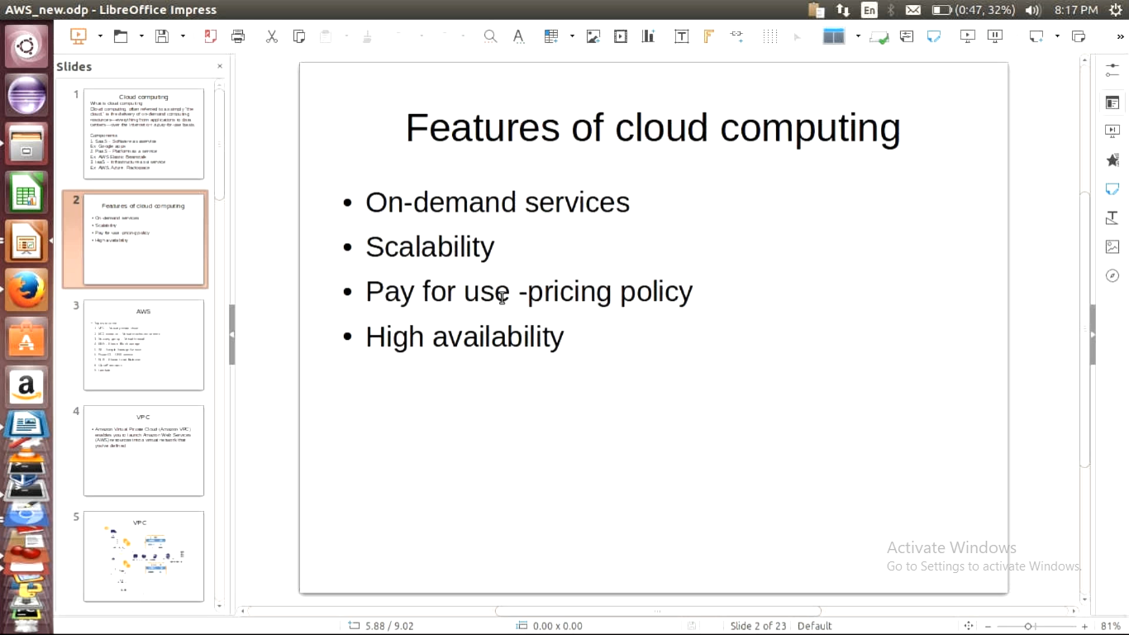

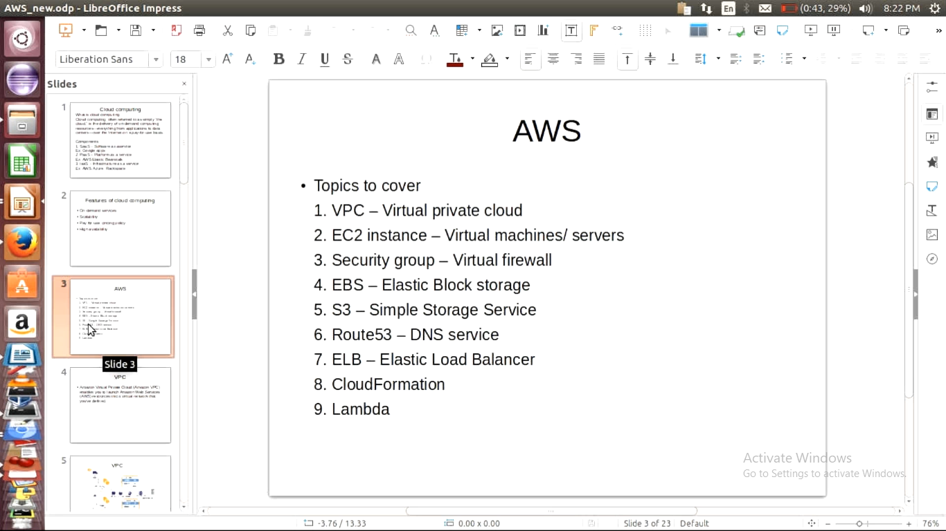

Services:

Vpc:

* Creating private network in aws
* For security pupose creating our own network and hosting services on our own network

EC2(elastic cloud compute):

->servers in aws is called ec2 instance.

->ec2 using send virtualization in aws

Security group:

->this firwall where we can resrict the accesing servers

EBS(elastic block storage)

->generally we will call disks but in aws we will ebs

S3(simple storage service)

->remote storage service which is cheaper than ec2

Route53

->DNS managent service in AWS

ELB(ealstic load balancer):

* It’s like nginx load balncer and elb is load alancer provided in AWS

CloudFormation:

* To launch a cluster of servers to automate it will helps( cloud formation)

Lambda:

It is a service to run server less applications.

Python boto

=======vpc==============

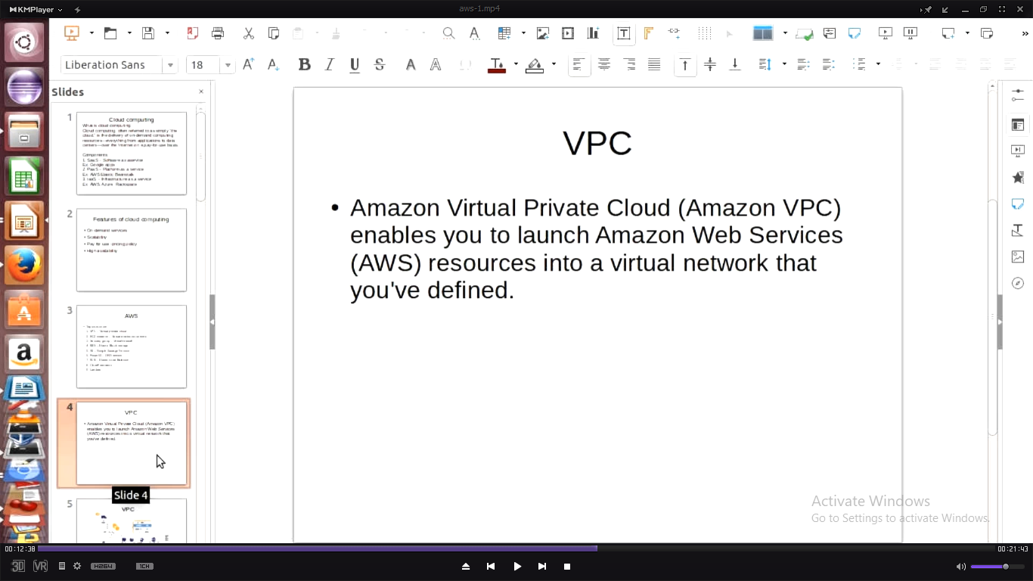

Private Ip : is accessible inside only inside particular network

Public Ip : any one can accesses globally

IP Adress classes:

<http://www.vlsm-calc.net/ipclasses.php>

Note:

Class A N/w: many no.of hosts and no.of networks is less

Class C N/w :Less no.of hosts and more no.of networks

->users will alays connect to load balancer

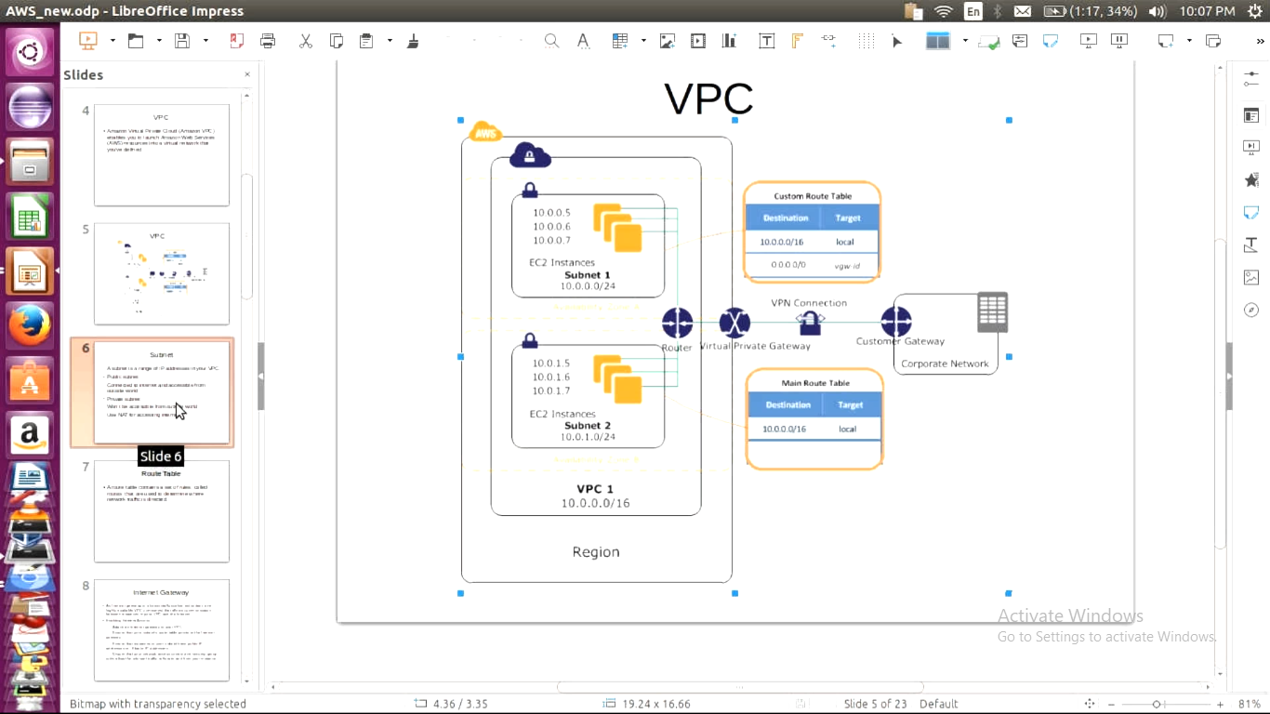

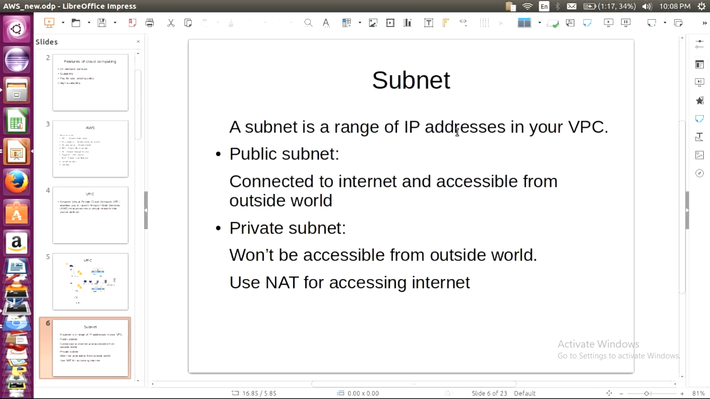

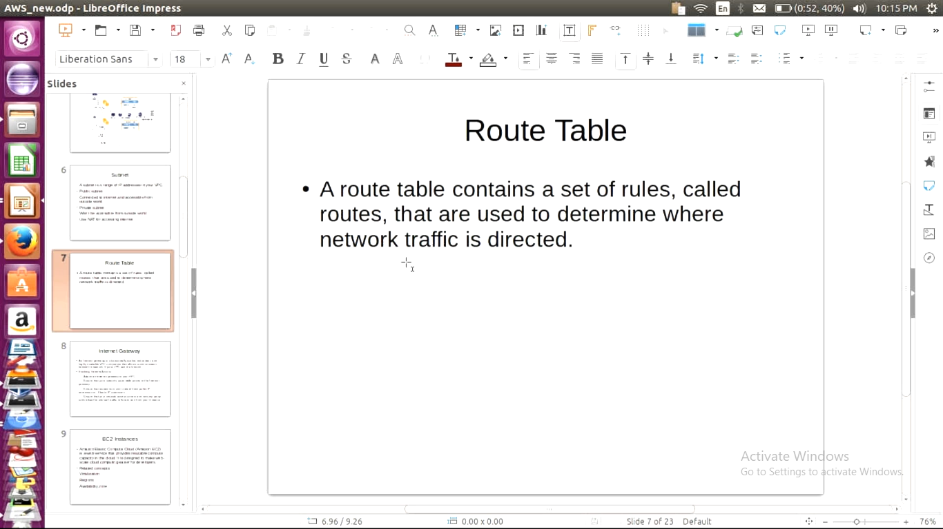

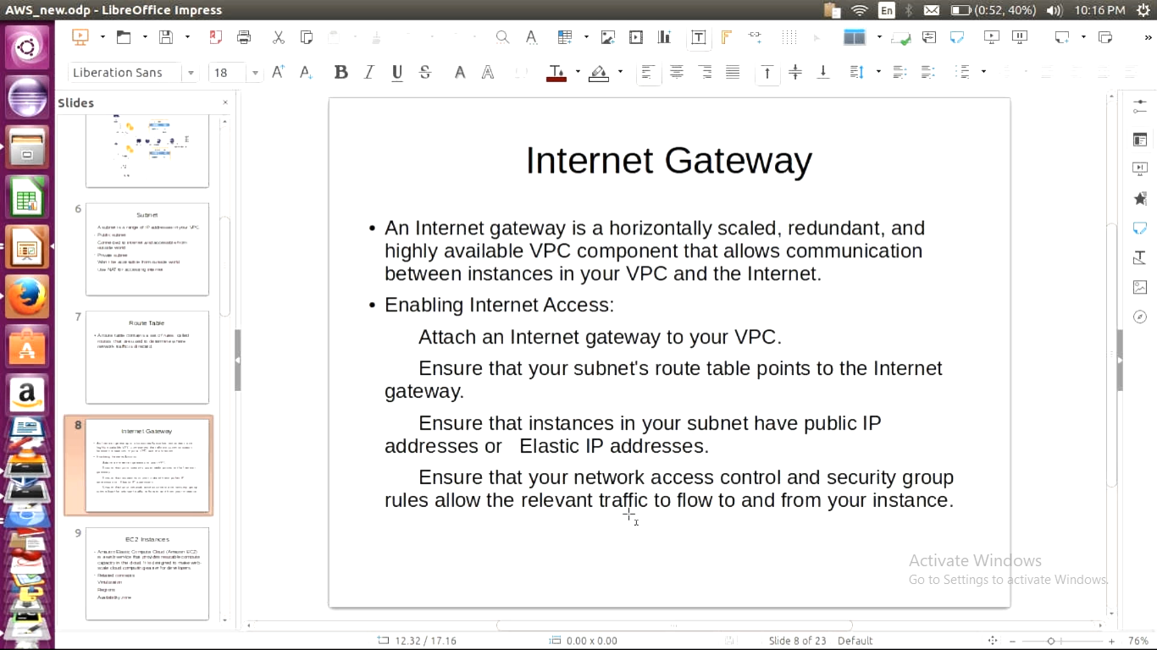

==================================== Create VPC========================================

Scenario:::::Create VPC

Navigate services -> Networking and content delivery -> vpc->create vpc

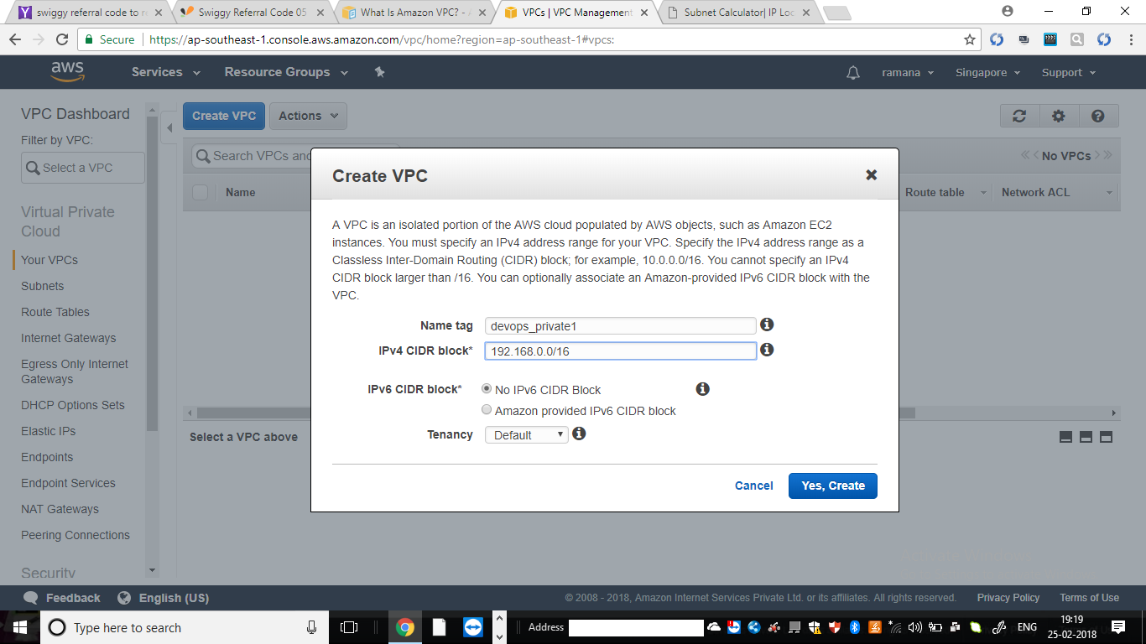

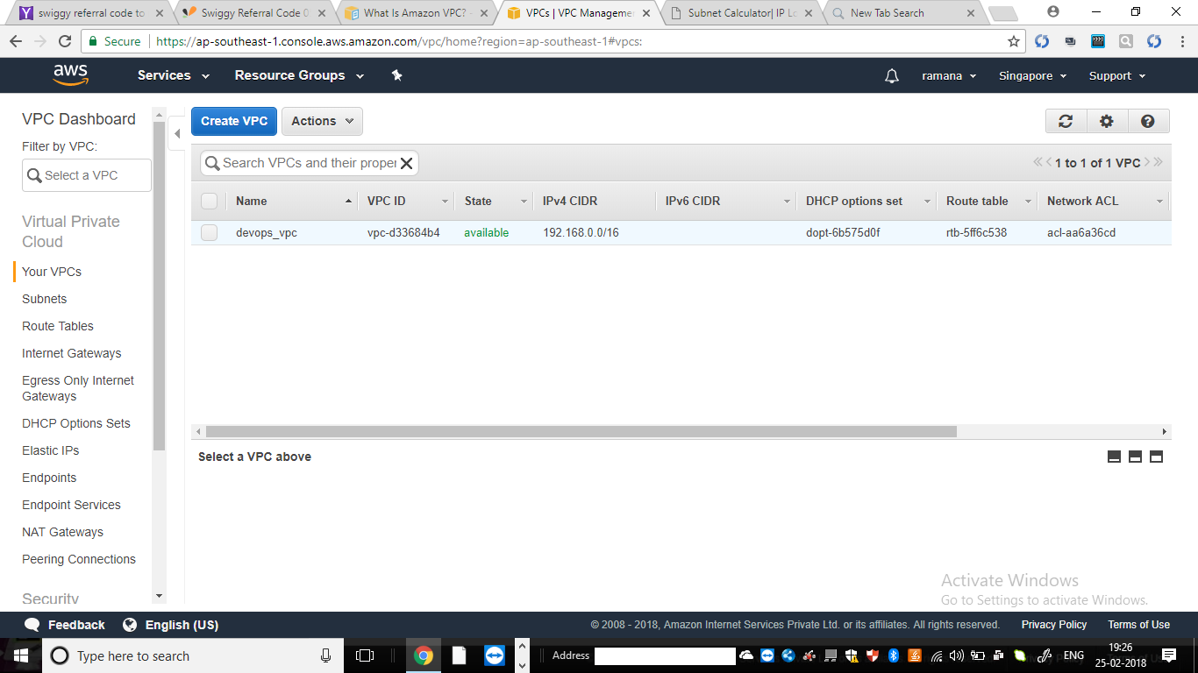

Scenario2:create subnets (public and private ) under vpc

Navigation:under vpc dashoard-> Subnets

Step1:creating public subnet

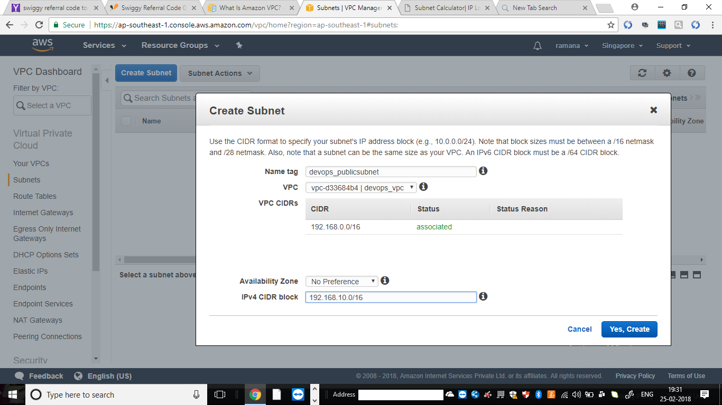

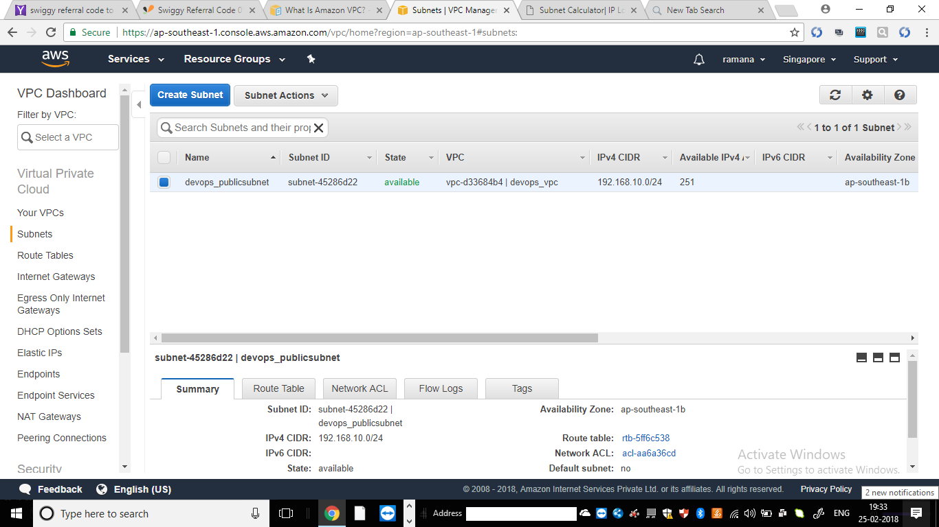

Sccenario3::: create internet gateway and attach vpv to IGW

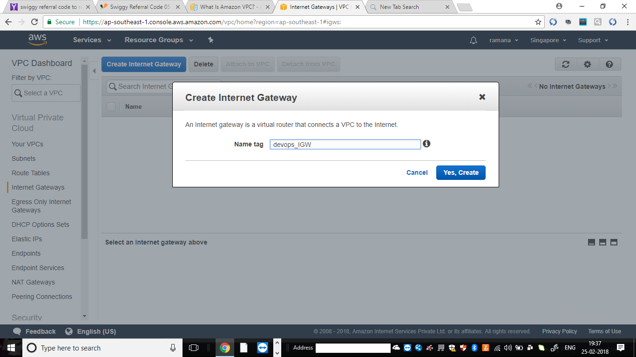

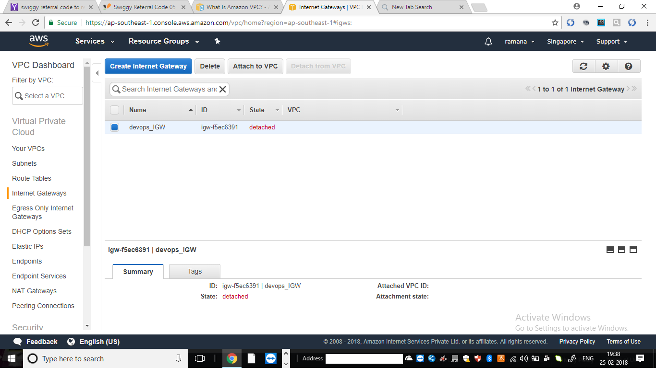

Click on “Attach to VPC”

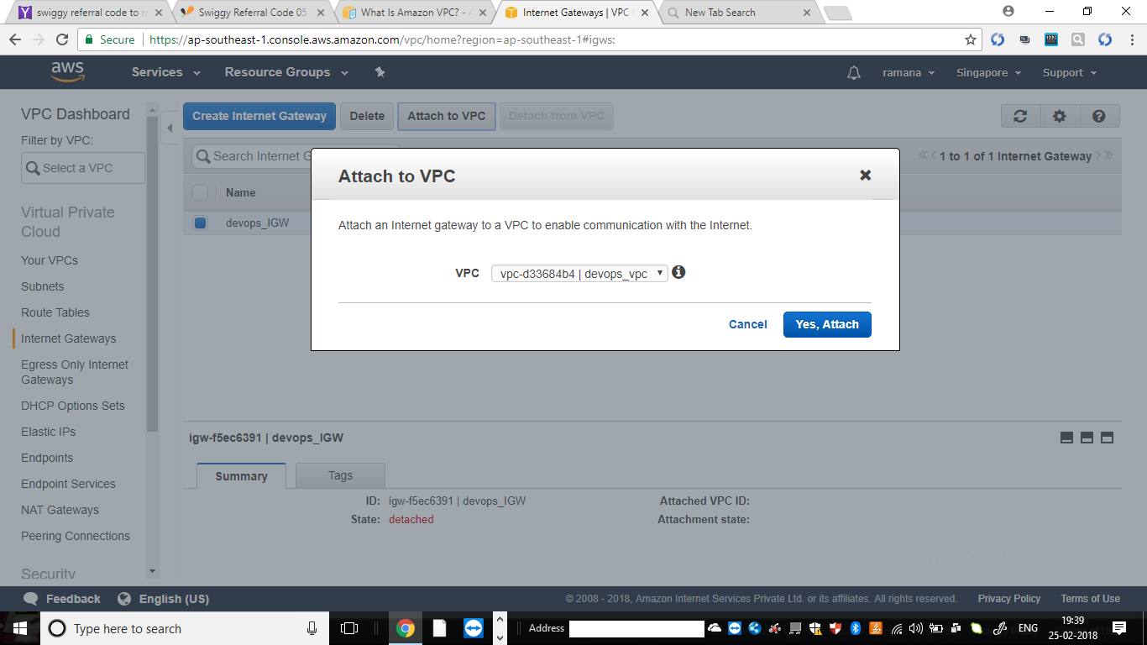

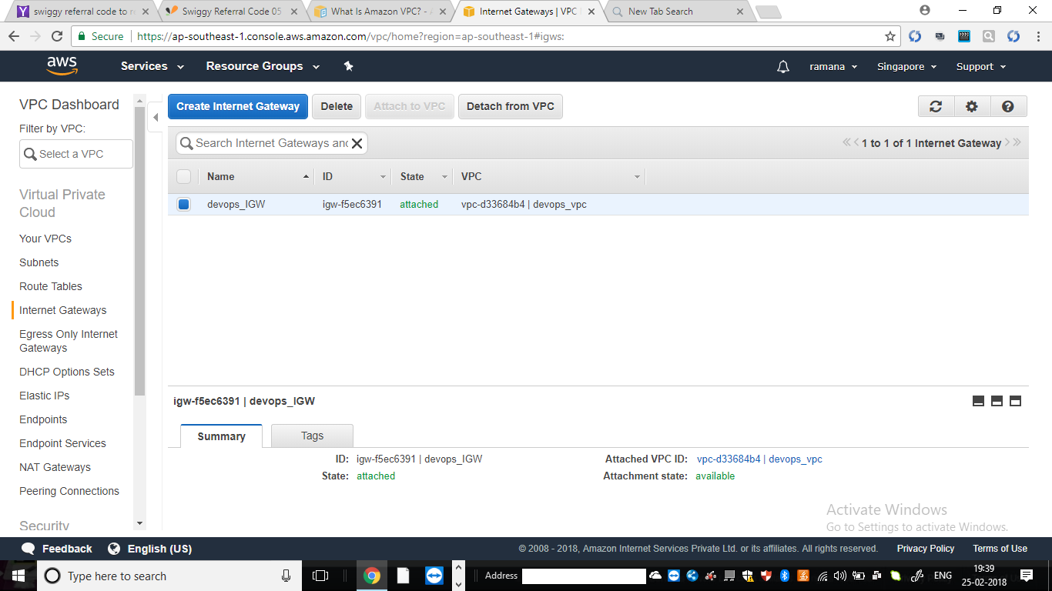

Sccenario4:create Route table

Step1:creating route table for public subnet

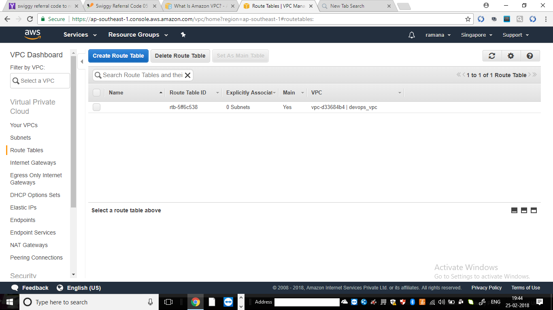

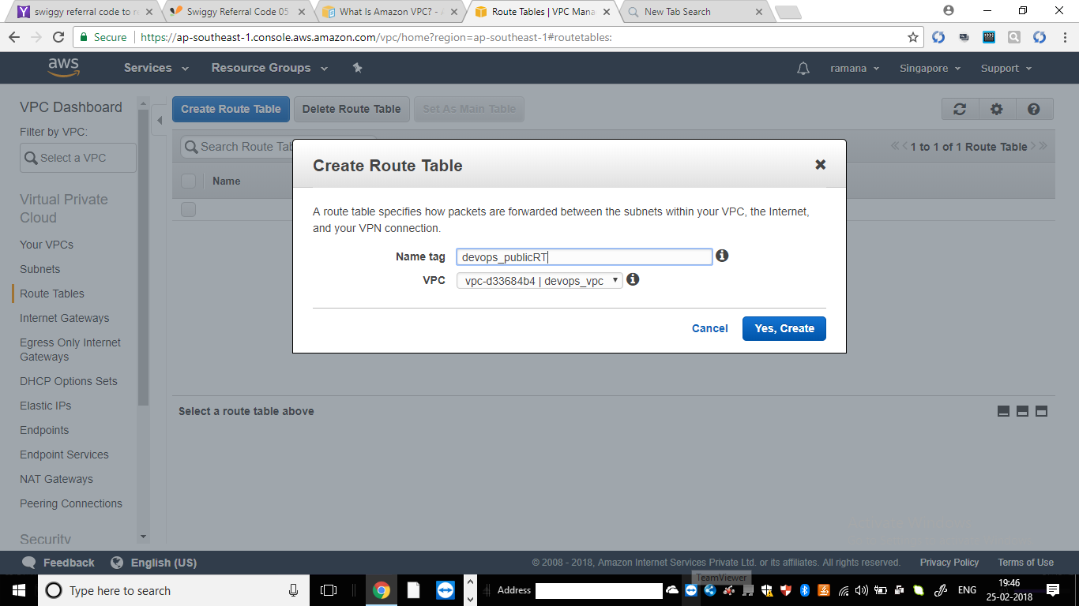

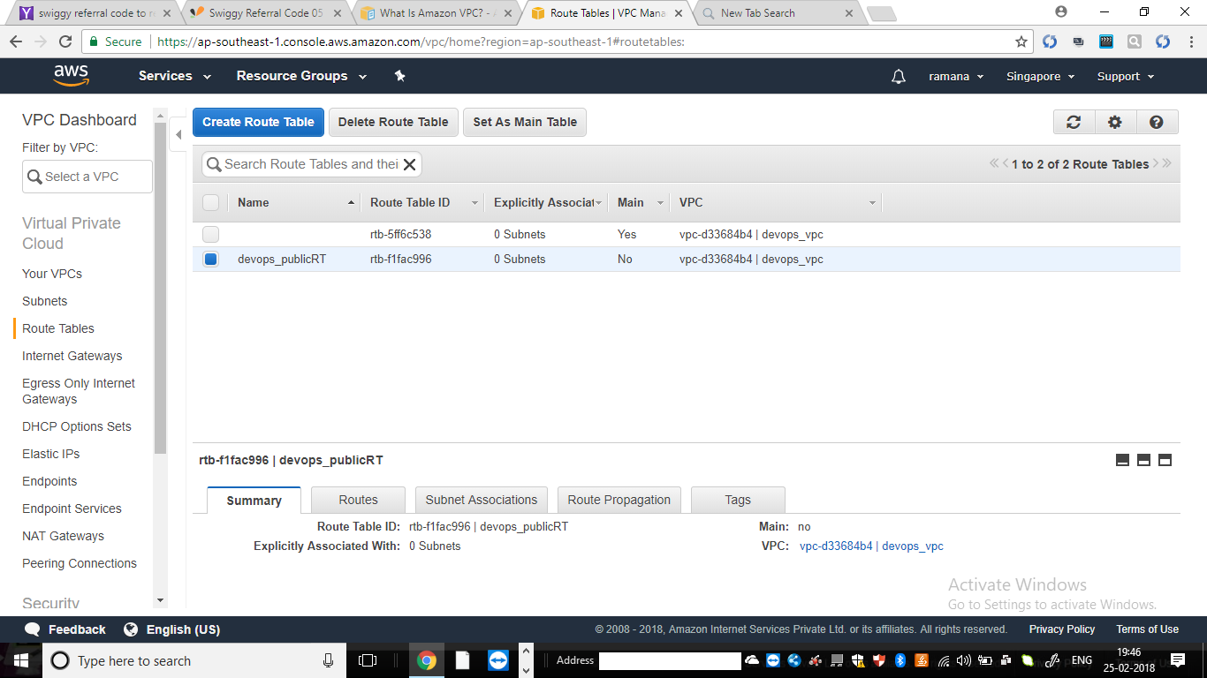

Add route to igw

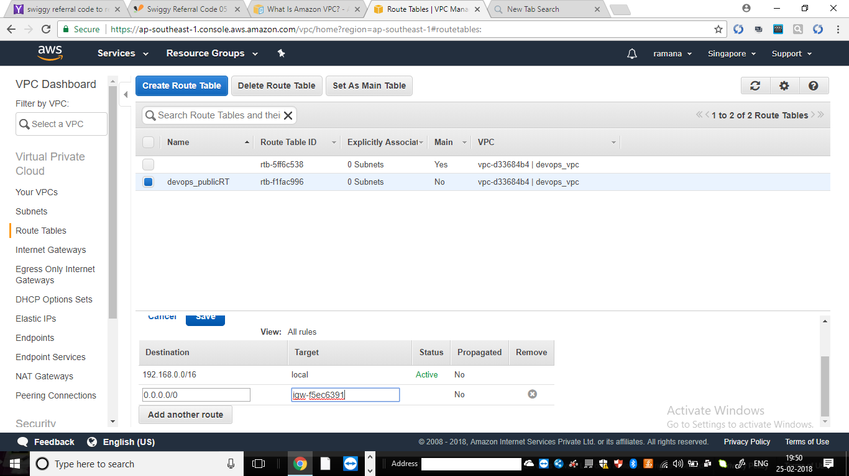

Scenario5:go back to subnets(public subnet) and route table of public

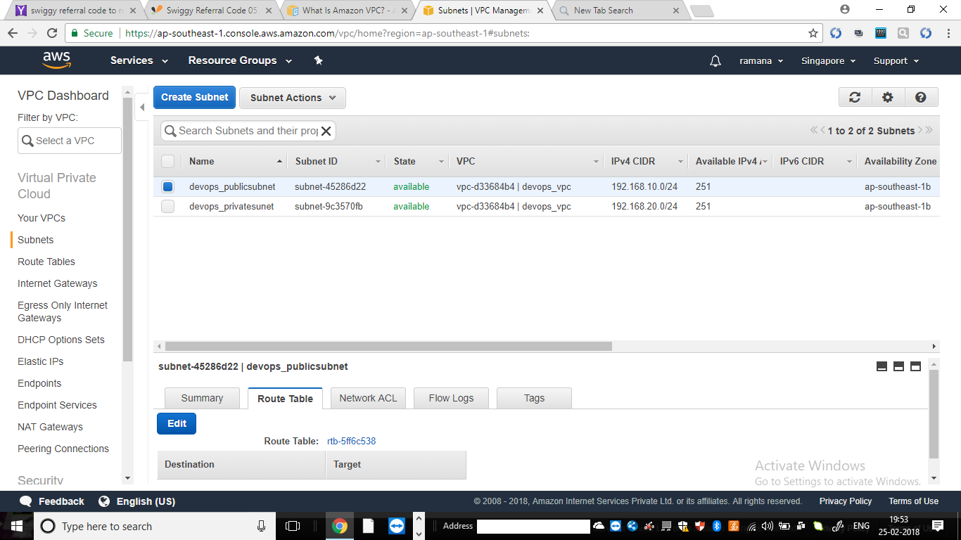

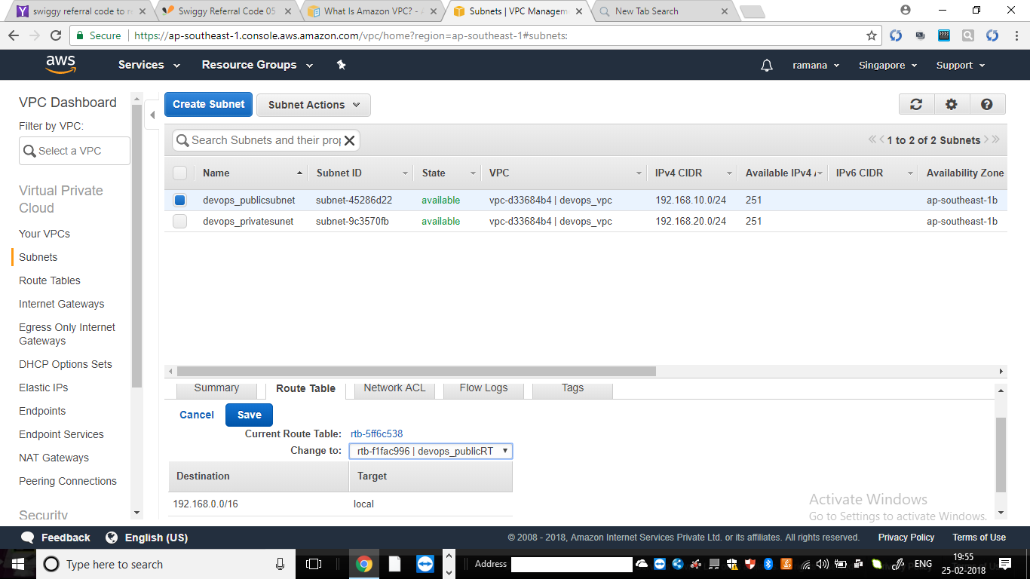

Vpc creation over view:

Log onto console ->while creating vpv consider that no.of hosts required and inside CIDR blok select the ip of class->after creating vpc create subnets (the cidr block is subset of vpc cidr block)->create IGW and add pulbic subnets and ->cnfigue the route tables to sunets and suppose if it is pprivate create NAT machine and route all private services through NAT.

============================================EC2====================================

EC2 –elastic compute cloud refers instances ,servers

Sccenario 1:launch ece2 instance (select region->

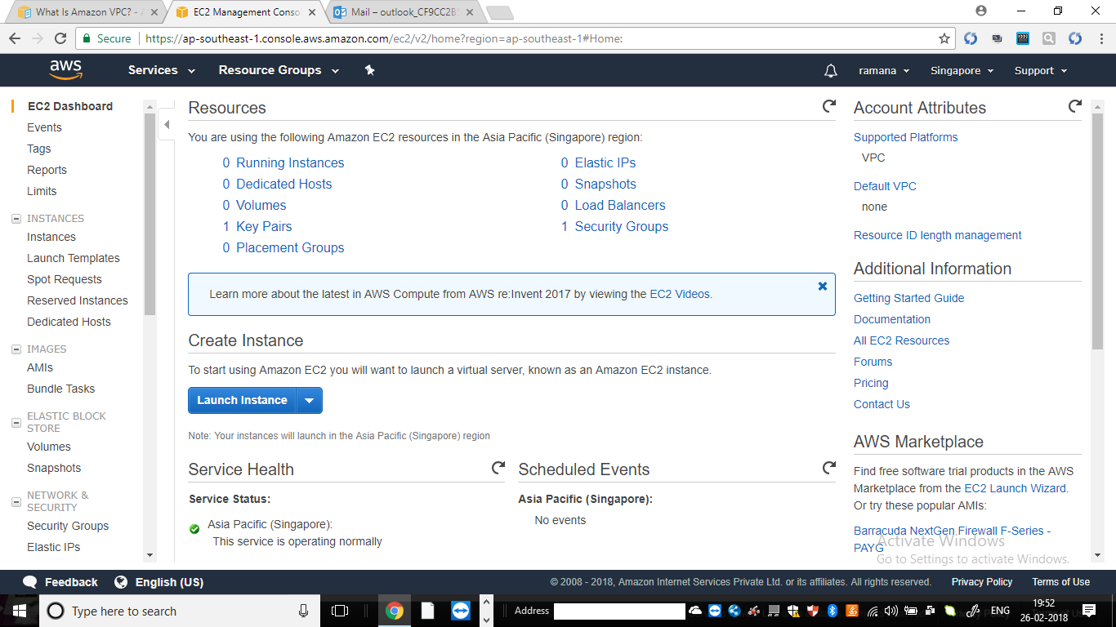

Aftr clicking launch quick start ->community AMI->search with image(ubuntu 14)and select->select instance

And click configure instance->

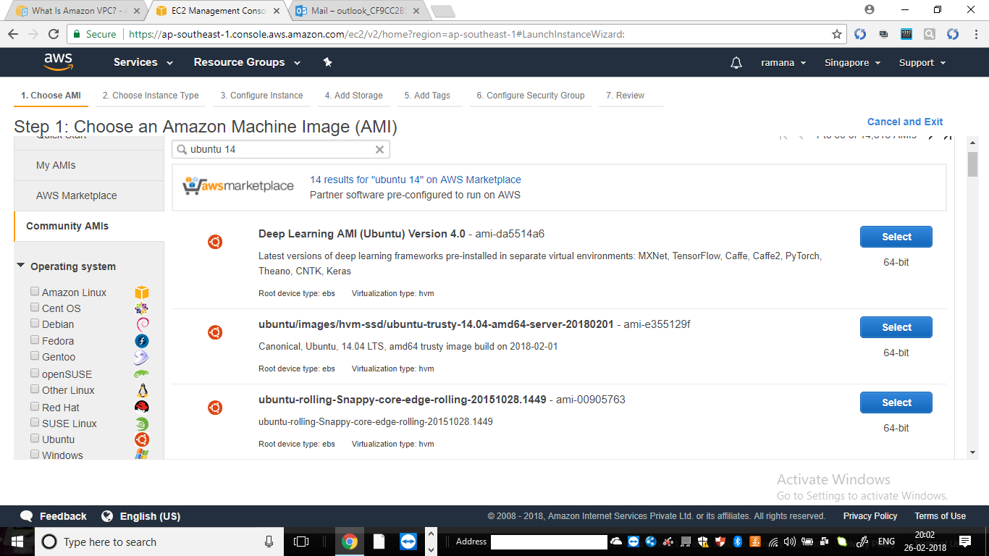

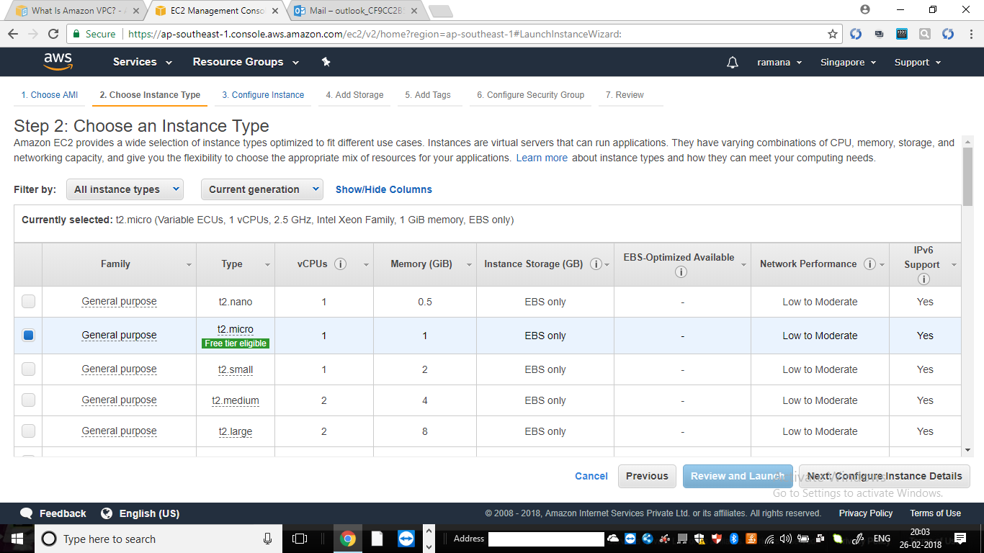

Step3::configure instance

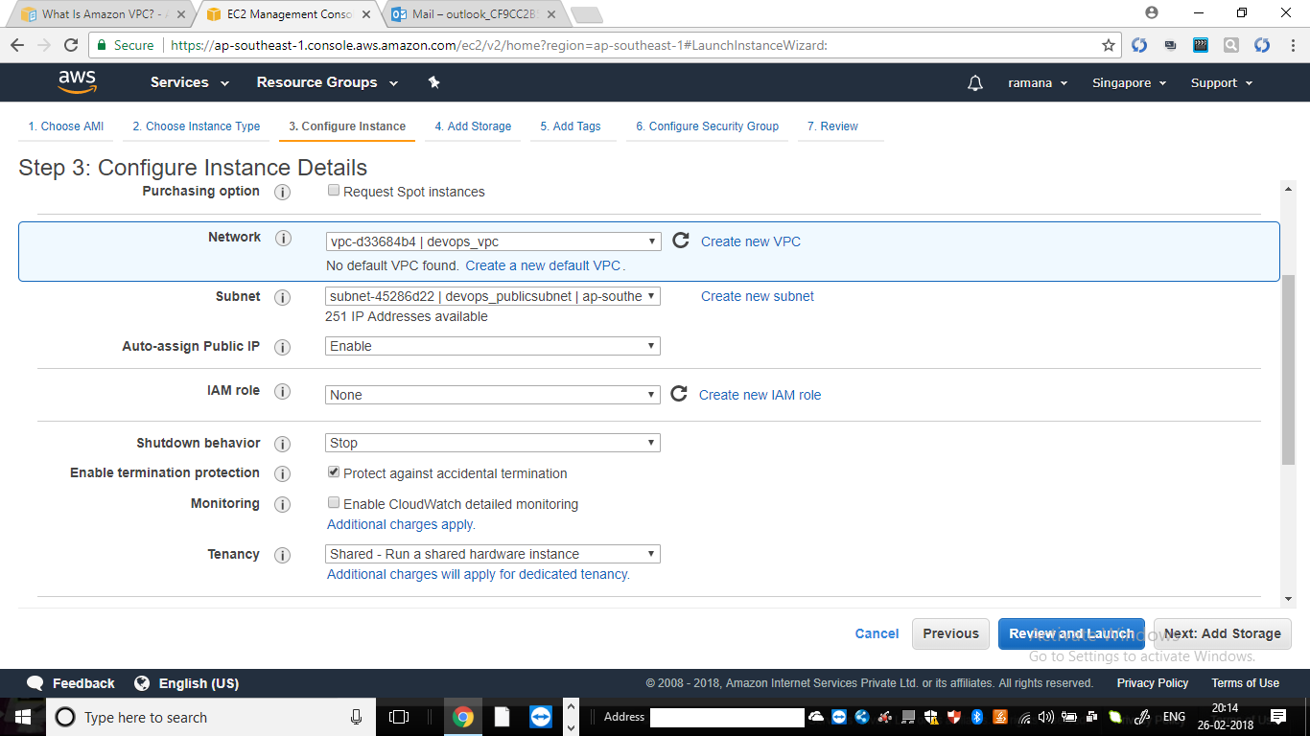

Step3:add storage

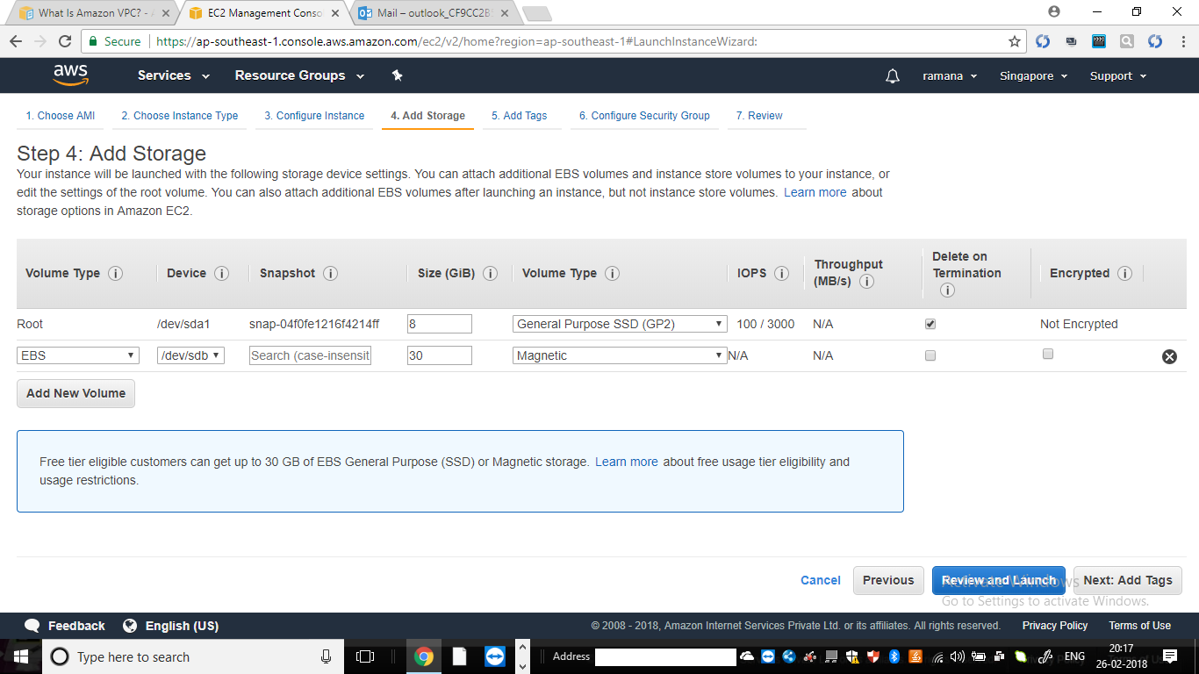

Step5:add tags

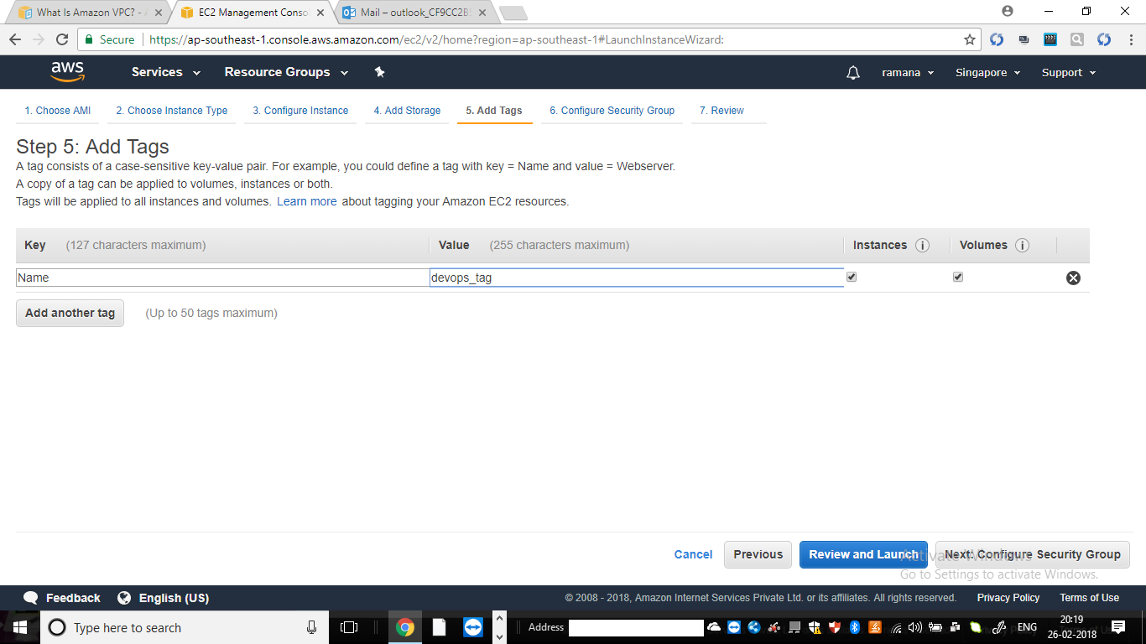

Step6:configure security group

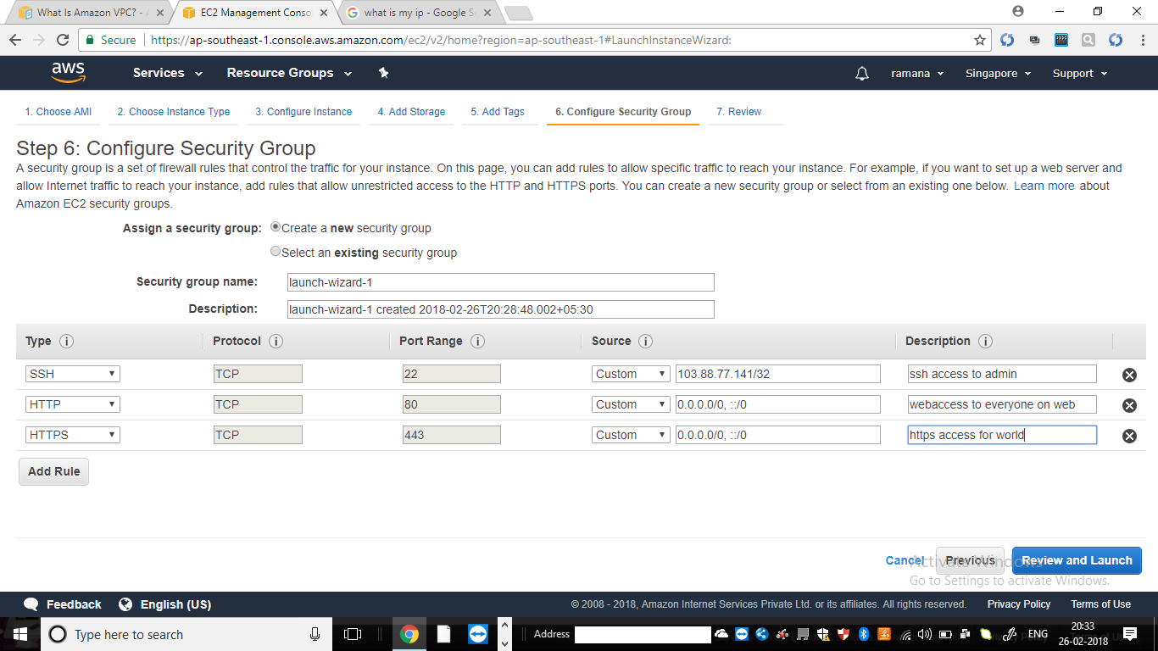

Review and launch

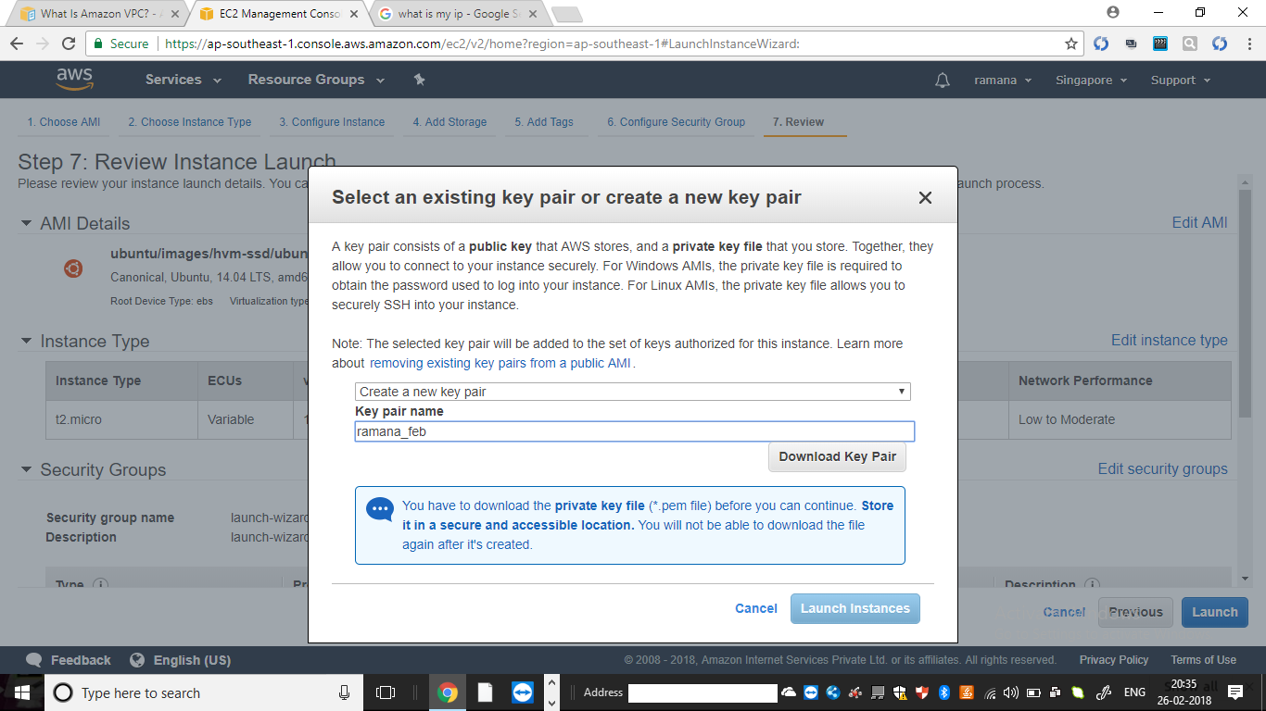

After launchin log into macine

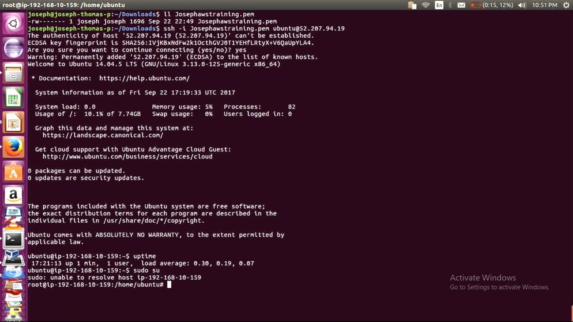

**============assingment======**

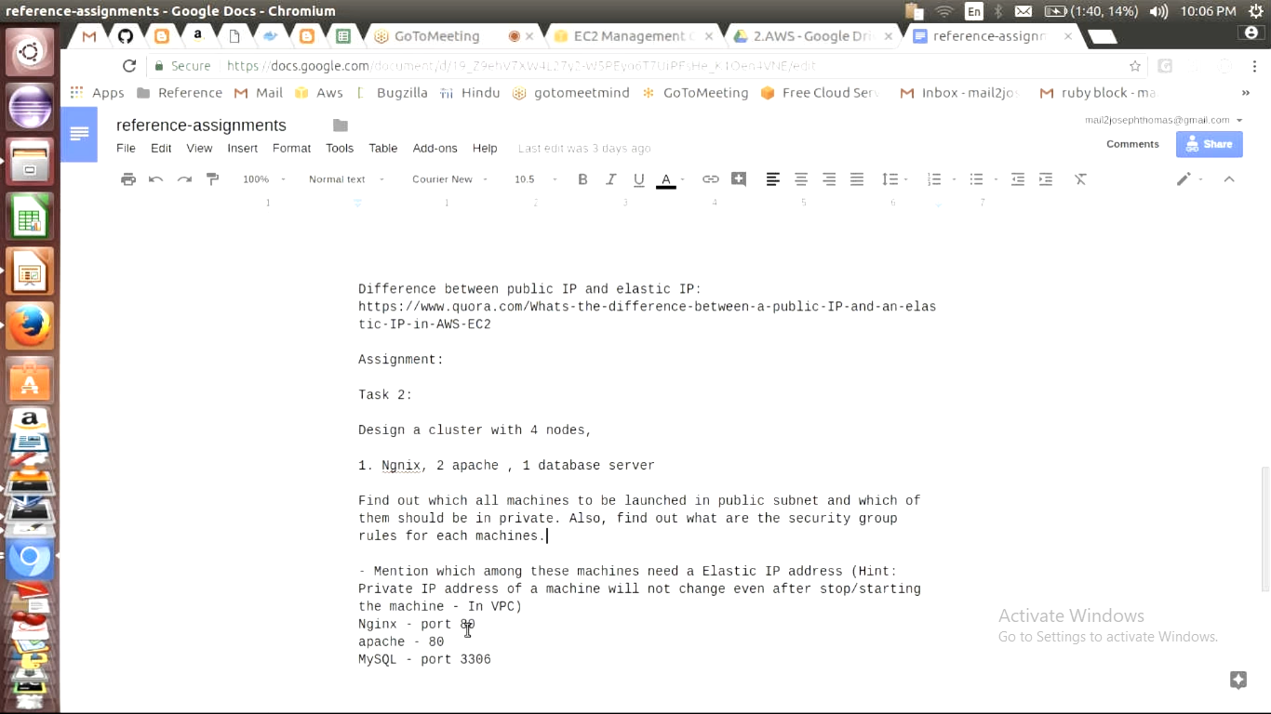

**=================================create security groups=================================**

**Rules to add ngnix:::::::**

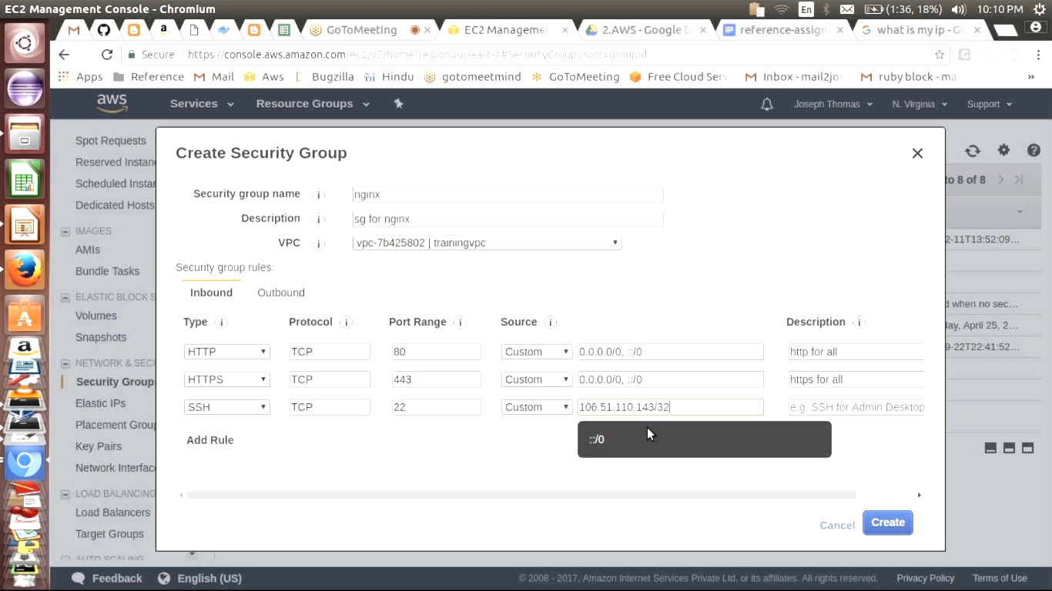

**Create security group for webserver::::::::**

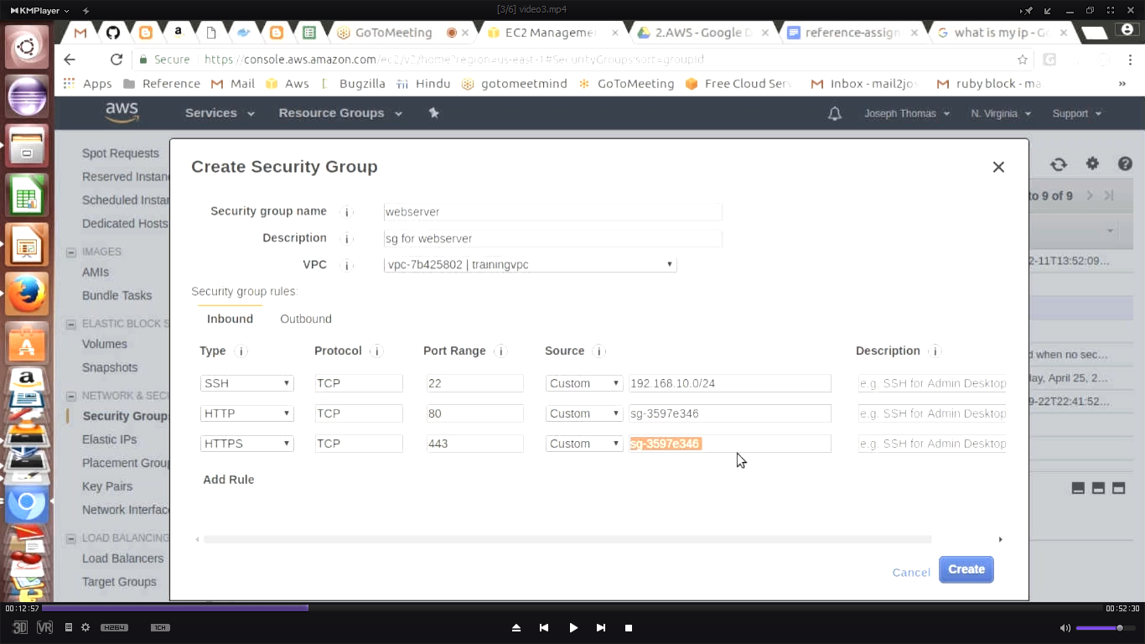

**HTTP and HTTPS are private subnets**

**Data base server::::::::::::;;**

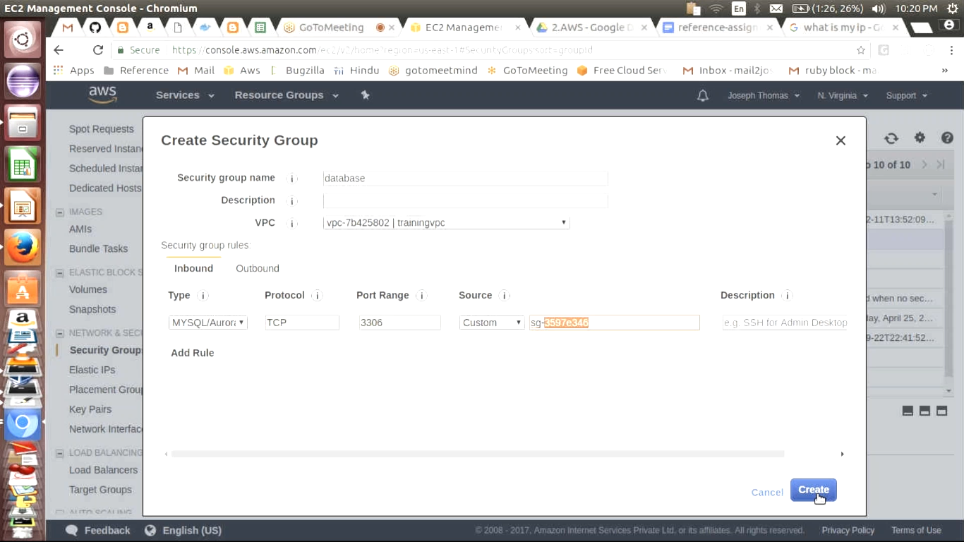

**Note: fsdisk –l show what are physical disks attached to machine**

**================how to create vloume and how to attach it to machine===============**

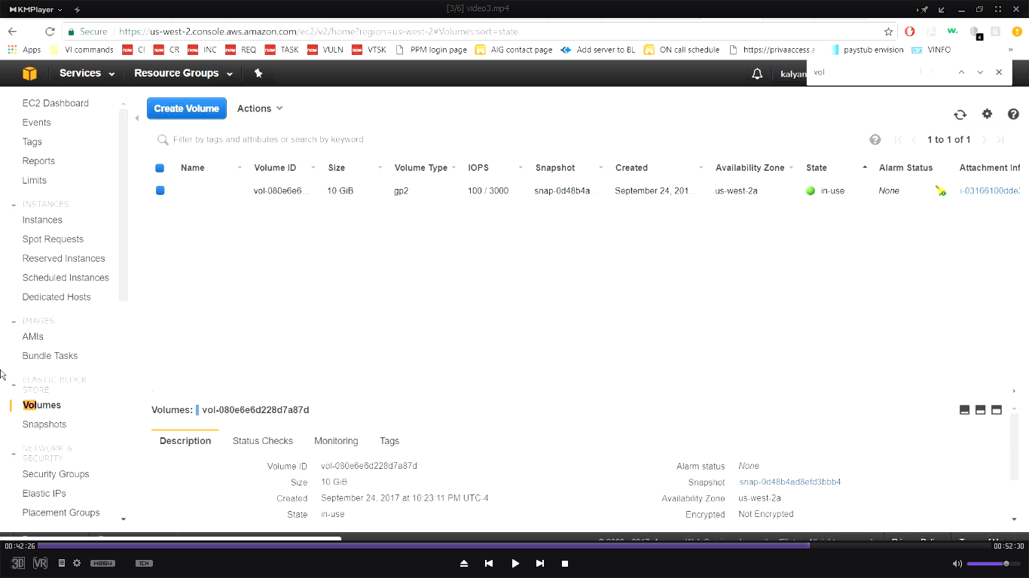

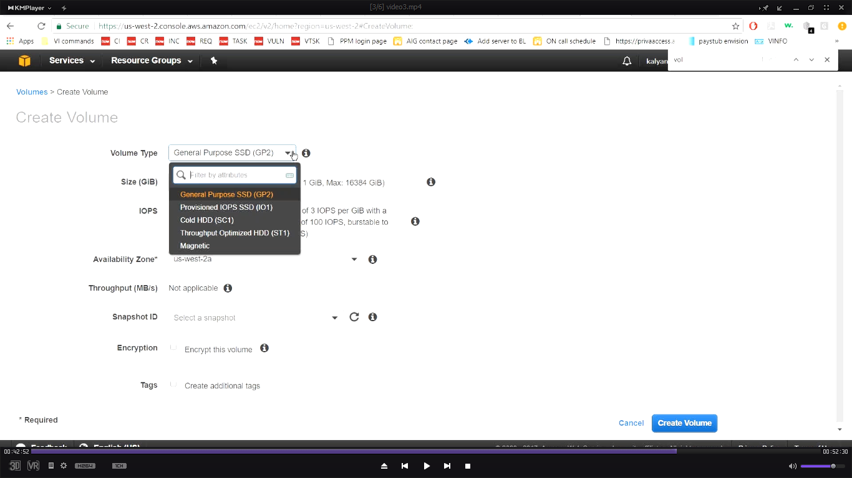

**GP2 is faster**

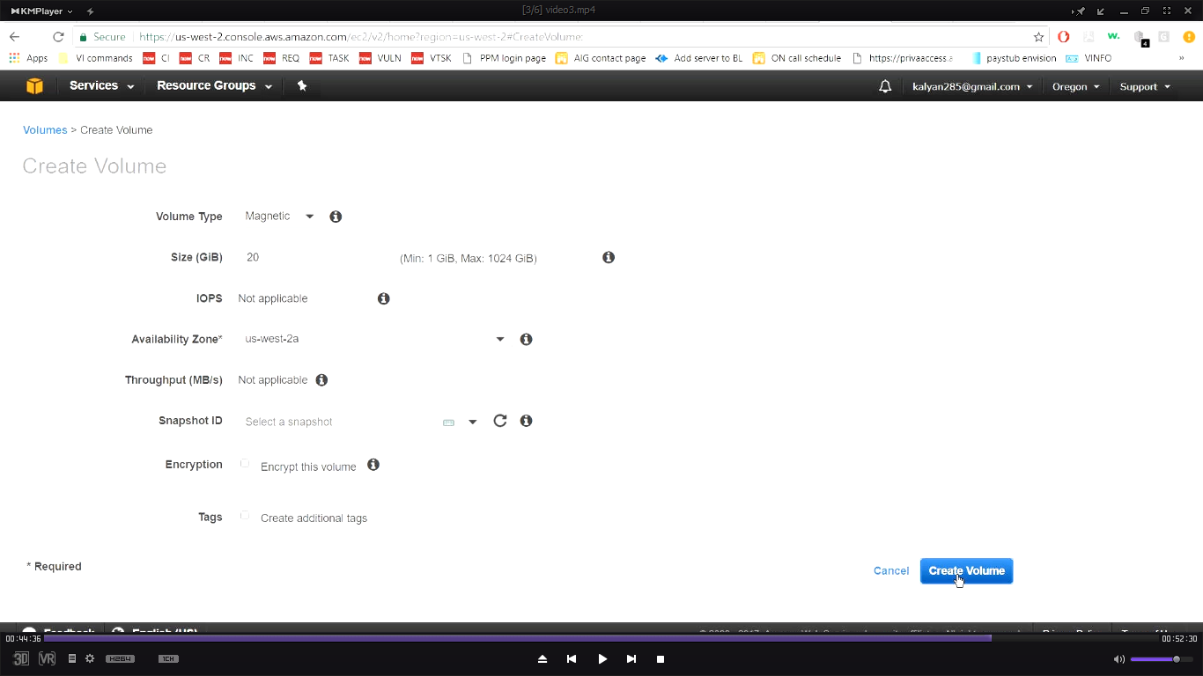

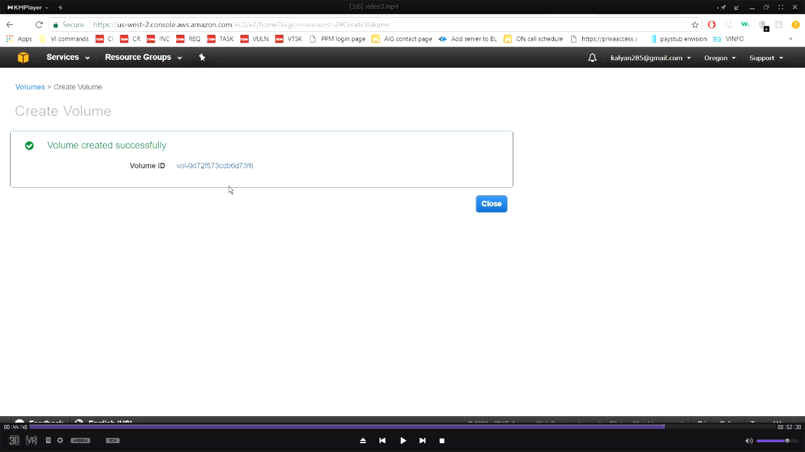

**Click on “volume” id**

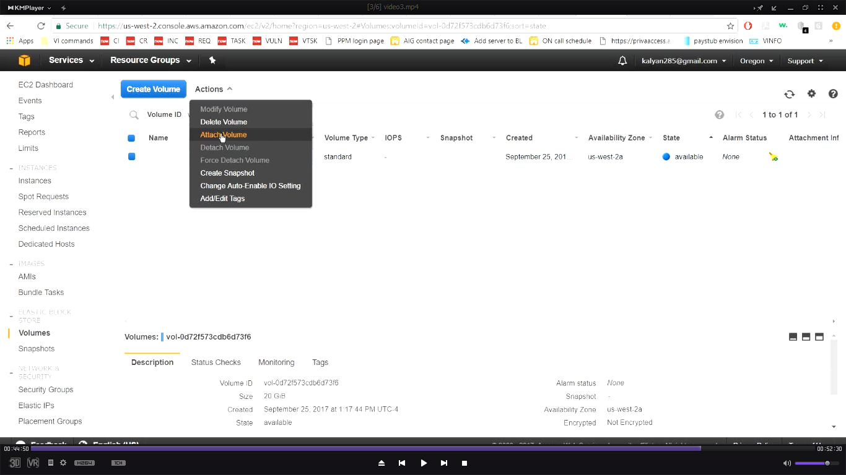

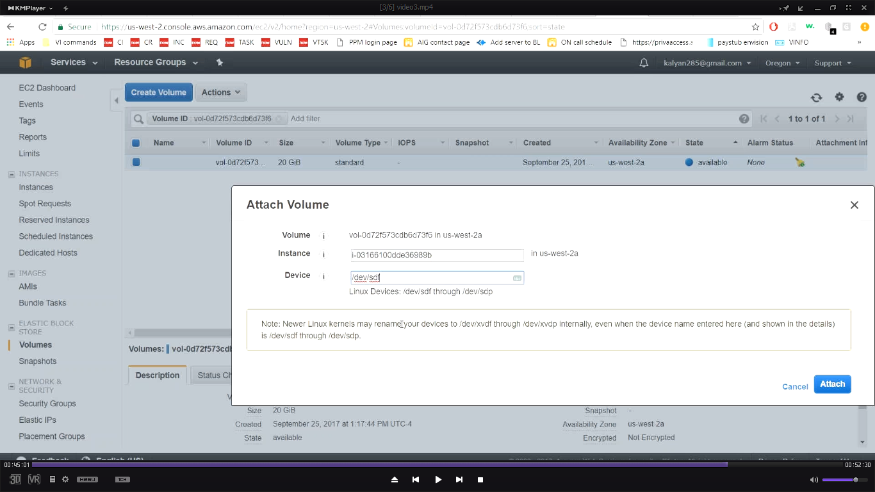

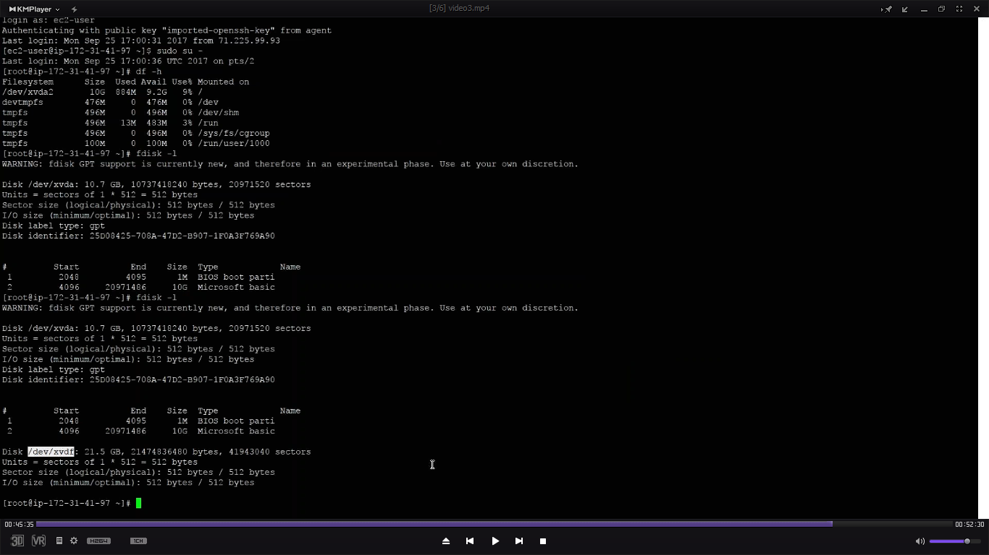

**How to create file system?**

